The Relational Database Management System, or **RDBMS** in short, manages relational data. Oracle Database is an RDBMS with the largest market share.



Besides the Oracle Database, there are other RDBMS products available. Here are some notable ones:

* Db2 from IBM.
* SQL Server from Microsoft.
* MySQL – the most popular open-source database, also from Oracle.
* PostgreSQL – the most advanced open source database.
* Oracle database is a relational database management system. It is known as Oracle database, OracleDB or simply Oracle. It is produced and marketed by Oracle Corporation..
* Oracle database is the first database designed for enterprise grid computing. The enterprise grid computing provides the most flexible and cost effective way to manage information and applications.

History of oracle:

* **Larry Ellison** and his two friends and former co-workers, **Bob Miner** and **Ed Oates**, started a consultancy called **Software Development Laboratories (SDL)** in 1977.
* SDL developed the original version of the Oracle software. The name *Oracle* comes from the code-name of a **CIA-funded project**
* Ellison had worked on while previously employed by .

Oracle Database features

Oracle Database allows you to quickly and safely store and retrieve data. Here are the integration benefits of the Oracle Database:

* Oracle Database is cross-platform. It can run on various hardware across operating systems including Windows Server, Unix, and various distributions of GNU/Linux.
* Oracle Database has its networking stack that allows application from a different platform to communicate with the Oracle Database smoothly. For example, applications running on Windows can connect to the Oracle Database running on Unix.
* ACID-compliant – Oracle is ACID-compliant Database that helps maintain data integrity and reliability.
* Commitment to open technologies – Oracle is one of the first Database that supported GNU/Linux in the late 1990s before GNU/Linux become a commerce product. It has been supporting this open platform since then.

Oracle Database has several structural features that make it popular:

* Logical data structure – Oracle uses the logical data structure to store data so that you can interact with the database without knowing where the data is stored physically.
* Partitioning – is a high-performance feature that allows you to divide a large table into different pieces and store each piece across storage devices.
* Memory caching – the memory caching architecture allows you to scale up a very large database that still can perform at a high speed.
* Data Dictionary is a set of internal tables and views that support administer Oracle Database more effectively.
* Backup and recovery – ensure the integrity of the data in case of system failure. Oracle includes a powerful tool called Recovery Manager (RMAN) – allows DBA to perform cold, hot, and incremental database backups and point-in-time recoveries.
* Clustering – Oracle Real Application Clusters (RAC) – Oracle enables high availability that enables the system is up and running without interruption of services in case one or more server in a cluster fails.

Oracle Database Editions

Oracle provides three main editions of Oracle Databases as follows:

1) Enterprise Edition (EE) is the common and expensive edition of the Oracle Database. It has the following characteristics:

* No maximum number of CPUs
* No limits on memory or database size
* Include premium features that are not available in other editions.

2) Standard Edition (SE) is a limited edition of the Enterprise Edition that has the following characteristics:

* Limited to four or fewer CPUs
* No limit on memory or database size
* Include many features, but no as many as EE

3) Expression Edition (XE) is a free-to-use version of the Oracle Database that available on both Windows and GNU/Linux platforms. These are the features of Oracle Database XE 18c:

* Limited to 2 CPUs
* Can use the maximum of 2GB of RAM, and has 12GB of user data.
* Very limited features
* What is a database
* A database is an organized collection of structured data stored electronically in a computer system.
* What is RDBMS?
* RDBMS stands for Relational Database Management System. RDBMS is the basis for SQL, and for all modern database systems like MS SQL Server, IBM DB2, Oracle, MySQL, and Microsoft Access.
* A Relational database management system (RDBMS) is a database management system (DBMS) that is based on the relational model as introduced by E. F. Codd.
* What is a table? The data in an RDBMS is stored in database objects which are called as tables. This table is basically a collection of related data entries and it consists of numerous columns and rows.
* Remember, a table is the most common and simplest form of data storage in a relational database. The following program is an example of a CUSTOMERS table:
* Below is an example of an Employee table.

|  |  |  |  |
| --- | --- | --- | --- |
| **ID** | **Name** | **Age** | **Salary** |
| 1 | Adam | 34 | 13000 |
| 2 | Alex | 28 | 15000 |
| 3 | Stuart | 20 | 18000 |
| 4 | Ross | 42 | 19020 |

### **What is a Tuple?**

* A single entry in a table is called a **Tuple** or **Record** or **Row**. A **tuple** in a table represents a set of related data. For example, the above **Employee** table has 4 tuples/records/rows.

### **What is an Attribute?**

* A table consists of several records(row), each record can be broken down into several smaller parts of data known as **Attributes**. The above **Employee** table consist of four attributes, **ID**, **Name**, **Age** and **Salary**.
* 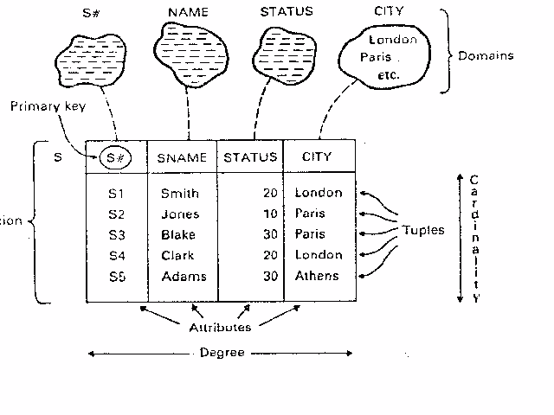
* **Introduction to SQL,**
* SQL is Structured Query Language, which is a computer language for storing, manipulating and retrieving data stored in a relational database
* SQL is a language to operate databases; it includes database creation, deletion, fetching rows, modifying rows, etc. SQL is an ANSI (American National Standards Institute) standard language, but there are many different versions of the SQL language.
* SQL is the standard language for Relational Database System. All the Relational Database Management Systems (RDMS) like MySQL, MS Access, Oracle, Sybase, Informix, Postgres and SQL Server use SQL as their standard database language.
* **Rules for SQL**
* Sql starts with a verb. E.g. Select statement
* Each verb is followed by number of clauses E.g.. From , where , Having.
* A space separates clauses E.g. Drop Table EMP.
* A semi colon(;)is used to end SQL statements.
* A statement may splits across lines but keyword may not.

**Data Types in oracle**

1. Char(Size):-used to store character string values of fixed length. It can be hold up to 2000 char.(Oracle 10g)
2. Varchar or Varchar2:- It is used to store variable length of record alpha numeric data up to 4000 char.(oracle 10g)
3. Number(P,S):-It is used to store numbers fixed or floating. P is total size, S number of Decimal places.
4. Date :- Used to store date data. The standard date format for date is DD-MM-YY HH:MI:SS.
5. Long:- used to store variable length character up to 2GB. It can not be indexed or SUBSTR() function can not be applied on Long Data type.
6. Raw /Long raw:- Used to store Binary data Like image or Pictures
   * + - * Raw size=255 byte
         * Long raw=2GB it can not be indexed.

SQL is consists of following language

1. Data Definition Language(DDL)
2. Data Manipulation Language(DML)
3. Data Control Language(DCL)
4. Transaction Control Language(TCL)

By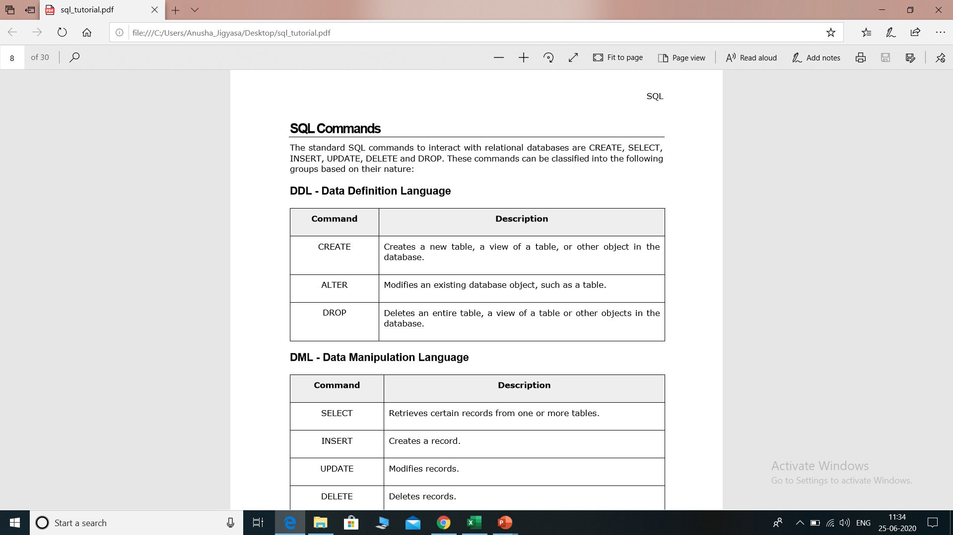

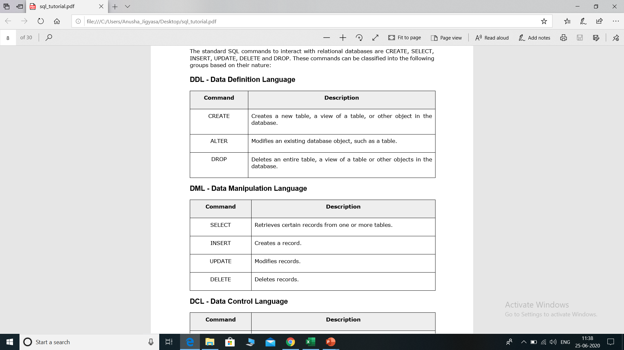

* **DCL Commands**
  + GRANT, REVOKE.
* **TCL Commands**
  + COMMIT ,ROLLBACK, SAVEPOINT.

## CREATE TABLE statement

The CREATE TABLE is a DDL statement which is used to create tables in the database. The table gets created as soon as the CREATE TABLE script is executed and is ready to hold the data onwards The user must have the CREATE TABLE system privilege to create the table in its own schema

* (definition:-column number, data type & size).
* Syntax

CREATE TABLE <Table Name>

(Coloumn name1 Datatype(size) ,

Coloumn name2 Datatype(size),

Column nameN Datatype(size));

The Oracle INSERT statement is used to insert a single record or multiple records into a table in Oracle.

The syntax for the Oracle INSERT statement when inserting a single record using the VALUES keyword is:

INSERT INTO table

(column1, column2, ... column_n )

VALUES

(expression1, expression2, ... expression_n );

The most commonly used query is a SELECT query. This query is used to retrieve data from one or more tables in the database. A SELECT query is not just used alone but with it, many conditions, clauses and inner queries are used to get data from databases

SELECT query does not manipulate any data in the table on which it is executed. Select keyword in oracle is applied for fetching a set of data, which can be used singly or by combining other conditional statements as filters. When a select statement is as ‘SELECT * from <Table_Name>’, the whole table is displayed as the result-set, whereas select statement as ‘SELECT *Column_1, Column_2*from <Table_Name>’ displays the contents of only the column_1 & column_2 of ‘<Table_Name>’. ‘Where’, ‘Group By’, ‘Order By’ conditions can also be applied at the end of the Select statement.

syntax

Select coloumn1,column2…….columnN from <table name>.

Example:-

**Selection of all row & all columns.**

SELECT * FROM student

**Column wise selection**

SELECT sname, fee from student;

**Row wise selection**

#### SELECT all fields with WHERE condition

SELECT * FROM student WHERE fee=10000;

**Row and Column wise selection**  
SELECT sname, fee from student where rollno=10;

#### **Display records in order using SELECT**

We can also display particular records in ORDER which can be ascending or descending by using the [ORDER BY clause](https://www.educba.com/order-by-in-mysql/) with the query. We will look at both ascending and descending order queries.

**a. Query for ascending order**

SELECT * from student ORDER BY name ASC;

#### SELECT query with GROUP BY clause

We use the GROUP BY clause with SELECT statement when we want to get records based on groups. So basically it groups rows that have the same values. It is used generally in conjugation with [aggregate functions](https://www.educba.com/aggregate-functions-in-sql/). It is useful in producing summary reports.

#### SELECT query with the HAVING clause

The [having clause](https://www.educba.com/oracle-having-clause/) is used with a select statement where we want to have some conditions as where keyword cannot be used directly with aggregate functions. That is the reason the having clause was added in SQL. We are going to see an example of how we can use the having clause with a select statement.

**Query:**

SELECT COUNT(EMPLOYEE_ID),VEHICLE_NAME FROM employee GROUP BY VEHICLE_NAME HAVING COUNT(EMPLOYEE_ID)> 2;

SELECT *column_name(s)*  
FROM *table_name*  
WHERE ROWNUM <= *number*;

SELECT * FROM Customers  
WHERE Country='Germany' AND ROWNUM <= 3;